**Front End Project Code Summary**

In this project, the main app was a travel app that was broken down into multiple smaller apps that would be useful for a person who was traveling or planning to travel. I worked a two week sprint doing front end work for the entirety of it. I enjoy doing front end work because it is satisfying to see it change and work that is not always as apparent in back end work. It is nice to know that you are changing and improving the what the user sees and their experience. I enjoy working with javascript, it is powerful, fast, and with enough work you can get a webpage to do pretty much whatever you can imagine. Working with javascript and jQuery is also great for me because since I’m not super familiar with it I always learn something new or a better way to do something. Working with CSS/HTML/Bootstrap is also always a rewarding challenge.

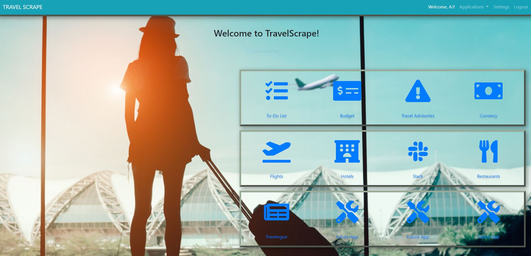

**First Homepage**



**My new Homepage**



**New homepage menu open**

|  |
| --- |
| $(userBackground);  **var** img = ["/static/images/traveling.jpg","/static/images/Airplane.jpg","/static/images/Beach.jpg","/static/images/Florence.jpg"]; **var** len = img.length; **var** current = -1; **for** (i **in** img){  console.log(i+' '+img[i]); }   **function** **changeBg**(dir) {  **if** (dir == 'right' && current < len - 1){  current++;  $('body').css('background-image', 'url(' + img[current] + ')');  console.log(current +" "+ img[current]);  localStorage.setItem('b', img[current]);  console.log(localStorage)  userBackground();  } **else** **if** (dir == 'left' && current > 0) {  current--;  $('body').css('background-image', 'url(' + img[current] + ')');  console.log(current +" "+ img[current]);  localStorage.setItem('b', img[current]);  console.log(localStorage)  userBackground();  }  }  **function** **userBackground**() {  **var** backgroundImage = localStorage.getItem('b');  **if** (backgroundImage) {  $('body').css('background-image', 'url(' + backgroundImage + ')');  } } |

**Javascript for background changing and storage**

|  |
| --- |
| **function** **openMenu**() {  document.getElementById("sideMenu").style.width = "250px"; } **function** **closeMenu**() {  document.getElementById("sideMenu").style.width = "0"; } |

**Javascript for opening and closing menu**

For the work on this page I first had to find a way to let the user switch between the choices for the background. Then I had to find a way to save and reload it on every page. It just needed to be saved on the browser and not to the users account so instead of saving it to a database I was able to store it to the localStorage where it could be called upon when each page was loaded. I did the menu in probably the simplest way possible by just having its width set to 0 and clicking on the menu button and bringing it out to 250px, and then back to 0px when the close button was clicked.